***Submitted By: Sankalp Raj*** ([sankalp.raj2020@vitbhopal.ac.in](mailto:sankalp.raj2020@vitbhopal.ac.in)) ***– 20BAI10271***

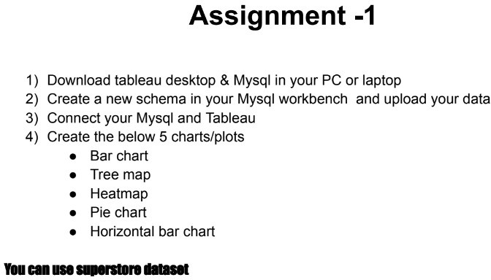

1. 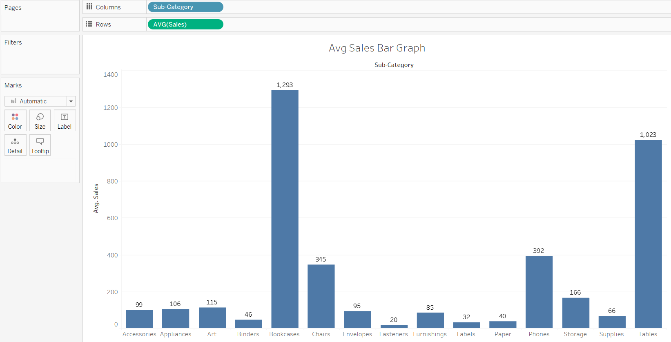**Bar Chart**
2. 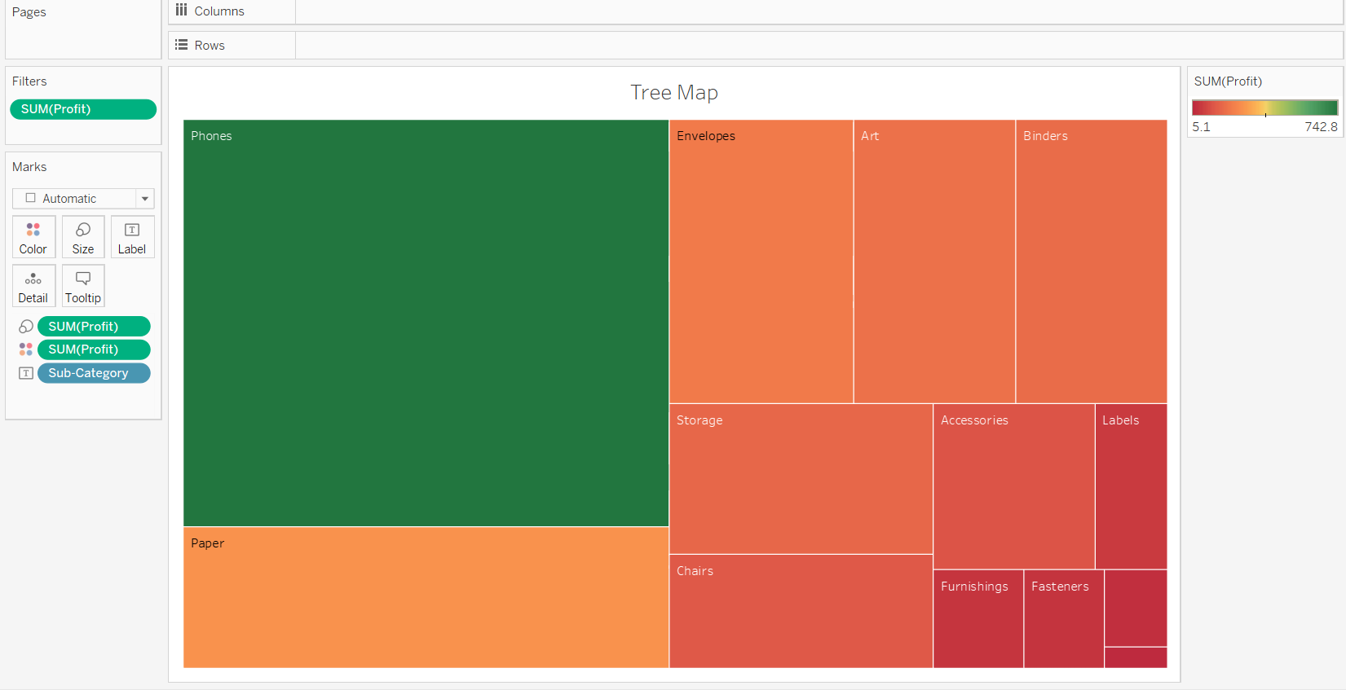**Tree Map**
3. 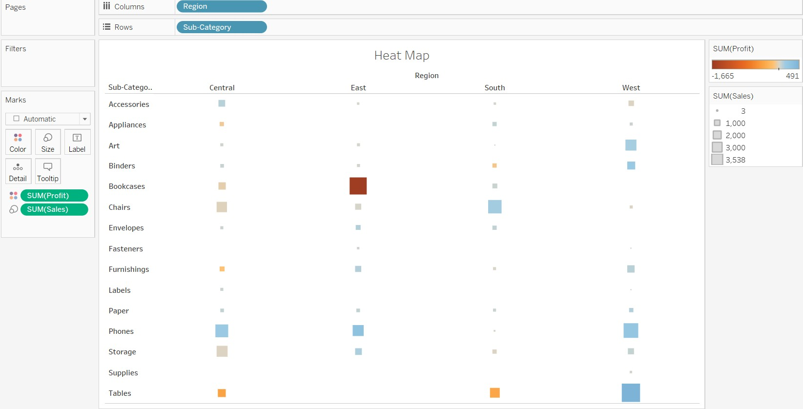**Heat Map**
4. 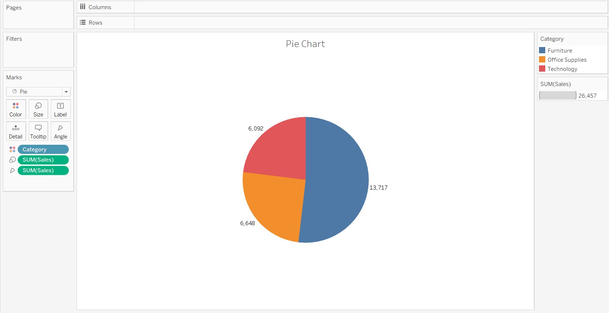**Pie Chart**
5. **Horizontal Bar Chart**

